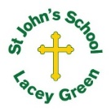
St John’s Church of England Primary School
‘Nurturing Potential within a Christian Ethos’

Knowledge Organiser
Prior Learning  Their local area.  Where Lacey Green is located.  Human and Physical features.  Simple map skills, including locating Lacey Green on a map. | Year 2 – Geography  Autumn 1  The United Kingdom  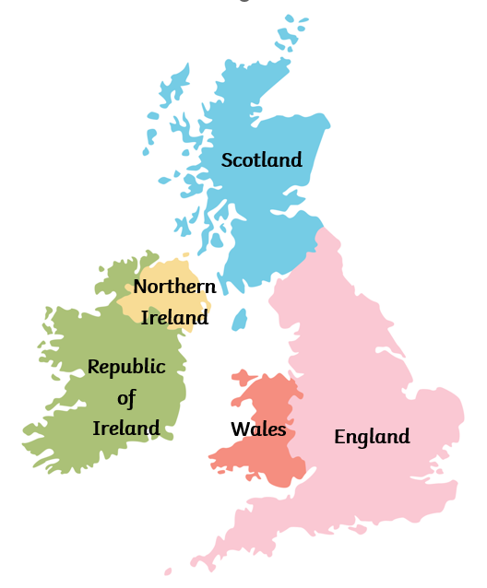 | Vocabulary  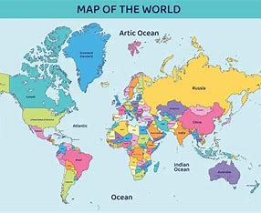  Country – Land that is controlled by a single government.  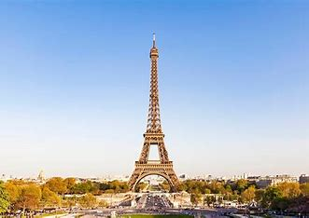  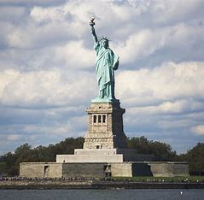  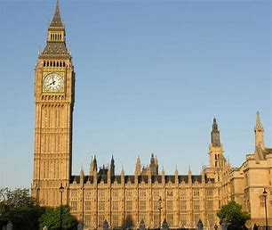  Landmark – Famous, easily identified geographic point.  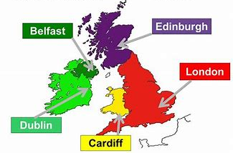  Capital City – The place from where the government of a country functions.
Key Skills Taught

Use world maps, atlases and globes to identify the locations of the United Kingdom and its countries.

Compare geographical features of towns and the countryside using their existing observations, maps and photographs.

Key Knowledge Taught: by the end of the unit pupils are expected to know that / be able to:  Countries that make up the UK - The four countries in the U.K are: England, Scotland, Wales and Northern Ireland.  What capital cities are and where they are in the UK - The capital cities of each country in the U.K. are: London, Edinburgh, Cardiff and Belfast.  What landmarks are.  Where the UK is in the wider world.  England is one of four countries in the U.K. London is the capital city of England. |  | Extra Information: This can be added to by teacher, parent or child  - Places that are important to me

