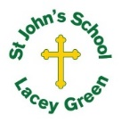
St John’s Church of England Primary School
‘Nurturing Potential within a Christian Ethos’

Knowledge Organiser
Prior Learning  Year 1/2- Children will have developed a strong basis of using historical disciplines such as chronology, similarity and difference, cause and consequence and handling historical artefacts. They understand that there is a past within their living memory and a past beyond that. Concepts such as trade, industry and settlement will have been mentioned but not explicitly taught. | Year Group - 2  Term  The Great Fire of London | Vocabulary  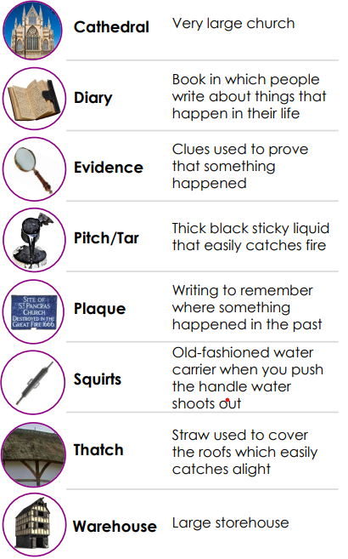
Key Skills Taught
· Realise that we use dates to describe events in time, eg: 1666 for the Great Fire of London.
· Know buildings were different during the 17th Century to how they are now, and this contributed to the causes of the fire.
· Make simple deductions from a picture / source. · How the Great Fire of London changed the landscape of London.
· A clear explanation of why the Great Fire took place with 2-3 clear reasons.
Key Knowledge Taught: by the end of the unit pupils are expected to know that / be able to:  1. Children understand how a small event, with a careless baker in a short narrow lane, can lead to a major rebuilding of vast areas of the capital.  2. They are able to explain that there were a variety of reasons for the fire and can suggest the most important ones.  3. They are able to describe the desperate measures taken to control the fire and can explain how Londoners felt at the time.  4. They can explain how the appearance of London changed after the Fire both the houses and the street layout and that the fire led to better fire service. |  | 

