
St John’s Church of England Primary School
‘Nurturing Potential for all within a Christian Ethos’

Knowledge Organiser
Prior Learning  - Identify and name a variety of common animals that are carnivores, herbivores and omnivores.  - Identify, name, draw and label the basic parts of the human body and say  - which part of the body is associated with each sense.  Key Skills Taught  - Observing how different animals, including humans, grow.  - Asking questions about what things animals need for survival and what humans need to stay healthy.  - Suggesting ways to find answers to their questions | Year 2 Science Autumn 2  Animals including Humans | Vocabulary
  adult | A fully grown animal or plant
  develop | To grow bigger and become stronger.
  diet | the food that an animal eats
  healthy | good for you
  hygiene | being clean in order to prevent illnesses
  life cycle | the stages an animal goes through throughout their life
  offspring | the babies that an animal produces
  reproduce | to produce offspring
  survive | to stay alive
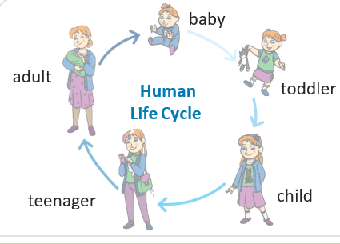
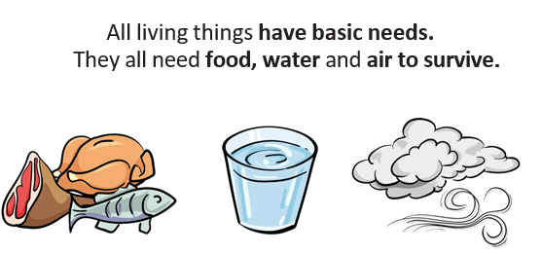
Key Knowledge Taught: by the end of the unit pupils are expected to know that / be able to:  - Animals, including humans, have offspring which grow into adults.  - In humans and some animals, these offspring will be young, such as babies or kittens, that grow into adults. In other animals, such as chickens or insects, there may be eggs laid that hatch to young or other stages which then grow to adults.  - The young of some animals do not look like their parents e.g. tadpoles.  - To grow into healthy adults, children also need the right amounts and types of food and exercise.  - Good hygiene is also important in preventing infections and illnesses. |  | Extra Information: This can be added to by teacher, parent or child

