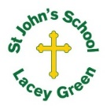
St John’s Church of England Primary School
‘Nurturing Potential within a Christian Ethos’

Knowledge Organiser
Prior Learning  In Year 1, we learned to describe materials and sort them by what they are like, such as hard or soft.  In the Autumn we learnt that eeverything around us is made from different materials.  We test materials to see which one works best. Some objects use more than one material.  Some materials can change shape. You can bend, stretch, squash, or twist them.  Key Skills Taught  Sorting materials,  testing materials for jobs,  asking simple questions  collecting information | Year 2 Science Spring 1  Properties of Materials | Vocabulary
  Absorbent | Soaks up water
  Absorbent | Soaks up water
  Brittle | Easy to break
  Brittle | Easy to break
  Flexible | Easy to bend
  Float | Stays on top of water
  Hard | Not easy to squash
  Sink | Goes to the bottom of water
  Soft | Easy to squash
  Waterproof | Does not let water through
 | 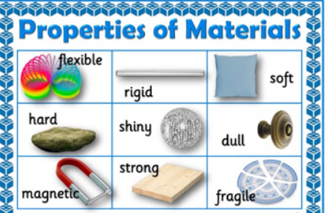
Key Knowledge Taught: by the end of the unit pupils are expected to know that / be able to:  Objects are made from materials chosen for a reason.  Some materials can be bent, stretched, twisted or squashed. |  | Extra Information: This can be added to by teacher, parent or child

