
St John’s Church of England Primary School
‘Nurturing Potential within a Christian Ethos’

Knowledge Organiser
Prior Learning:  Year 1  Children created their own felt puppets of Paddington Bear. Fabric was joined using hot glue guns.  Year 1/ Year 2  Create a design for a finished product and evaluated it against the design brief. | Year 2 – Summer 2  Design Technology  Textiles: Felt Sea Creatures  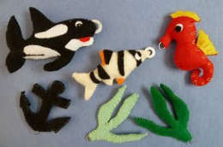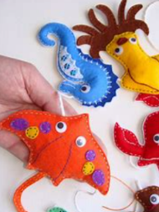 | Vocabulary
  Hand sewing  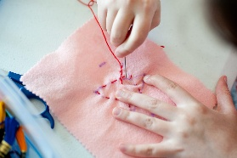 | Sewing is stitching cloth, leather, furs, or other materials, using a needle and thread.
  Needle  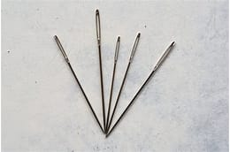 | a small tool used to push or pull a thread through a small hole.
  Thread  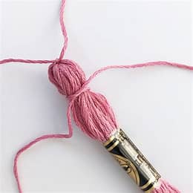 | A fine cord used in sewing, weaving, and other crafts.
  Sewing pattern | A drawn paper template used for cutting and sewing.
Key Skills Taught:
- To perform a running stitch using a needle and thread.
- Make their own paper sewing pattern to help cut their material ready sewing.
- How to pin fabrics together.
- Join fabric together using a running stitch.
Key Knowledge Taught: by the end of the unit pupils are expected to know that / be able to:  - Sewing is a method of joining fabric together.  - The running stitch is a basic sewing stitch (usually the first stitch to be introduced to those learning to sew).  - Paper sewing patterns are used to prepare fabric for cutting. |  | Extra Information: This can be added to by teacher, parent or child

