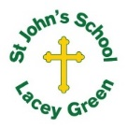
St John’s Church of England Primary School
‘Nurturing Potential within a Christian Ethos’

Knowledge Organiser
Prior Learning  Year 1  Use a variety of tools and techniques including the use of different brush sizes and types. Mix and match colours to artefacts and objects.  Cut and tear paper and other materials. Build layers of materials to create an image. Create images from imagination, experience or observation.  Year 2  Evaluate their finished artwork and compare to the style of a featured artist. | Year 2 -Art  Summer  Maud Lewis – Coastal Landscapes  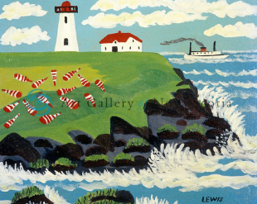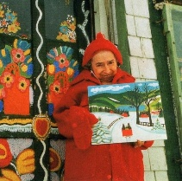 | Vocabulary
  landscape | All the land and sky that you can see from one point.
  Coastal | Where the land and sea meet.
  Colour mixing | Adding colours to together
  Shade | Adding black to darken a colour
  Tint | Adding white to lighten a colour
  Collage | Combining different materials to create a piece of art.
Key Skills Taught
- Use sketch books to gather visual imagery, experiment with techniques and develop ideas and designs (painting and cutting).
- Create textured collages from a variety of media. Use different kinds of materials to embellish and add detail.
Key Knowledge Taught: by the end of the unit pupils are expected to know that / be able to:  - Know that Maud Lewis was a Canadian folk artist who created brightly coloured landscapes from memory rather than painting live.  - Colouring mixing; create different shades and tints of colour by adding white to lighten and black to darken.  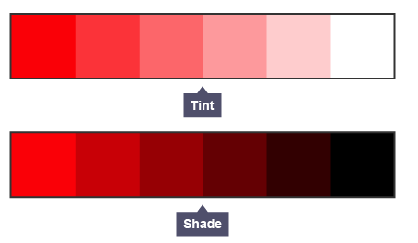  - Use scissors with greater precision to cut out a range of shapes differing in size. |  | Extra Information: This can be added to by teacher, parent or child

