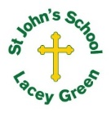
St John’s Church of England Primary School
‘Nurturing Potential for all within a Christian Ethos’

Knowledge Organiser
Prior Learning  Most pupils would have learned that:  - Brahman – one God in many forms, God in everything  - Murtis – Vishnu, Shiva, Ganesha  - Hindu worship – Arti, Puja, home shrine, Mandir  - Karma and Moksha – Samsara, Karma and Moksha  - Islam pilgrimage (Hajj) -Y5 topic  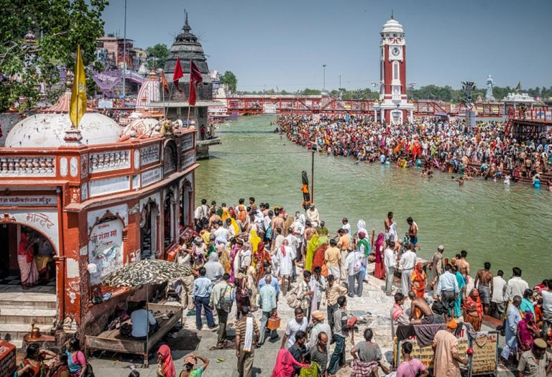 | Year 5 + 6: RE  Term: Summer 1  What might a Hindu gain from a pilgrimage to India?  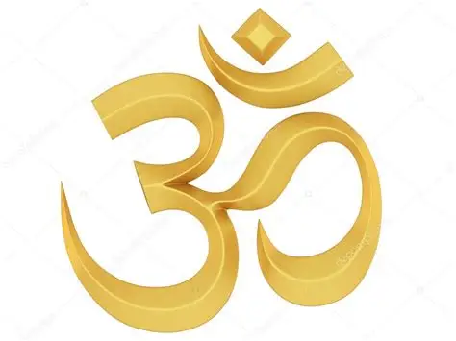 | Key Knowledge Taught: by the end of the unit pupils are expected to know that:  - Pilgrimage is not a requirement of Hindu faith but may be taken once or more in a lifetime  - There are many different pilgrimage destinations for Hindus  - Many of these centres are on the River Ganges  - Different deities are worshipped in different places  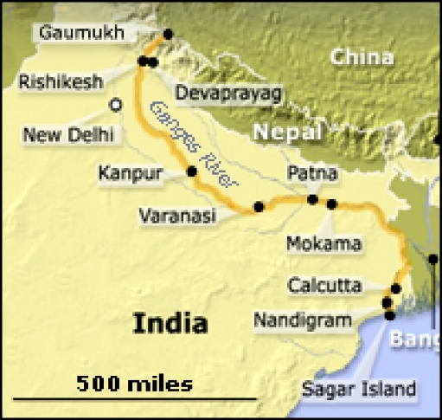
Vocabulary
Hindu: Someone who follows Hinduism.
Brahman: Hindus recognise one God, Brahman.. Dharma: To do the right thing with good behaviour.
Moksha: The ultimate goal. It happens when a soul stops being reincarnated and is reunited with Brahman.
Sacred:
Pilgrimage: A special religious journey that has a specific purpose
Pilgrim: A person who goes on a pilgrimage

Key skills taught and outcomes Be able to:  - Name and locate some pilgrimage sites for Hindus  - Describe what happens at different Hindu pilgrimage sites  - Identify and describe some of the reasons why Hindus may choose to go on a pilgrimage |  | Extra Information: This can be added to by teacher, parent or child

