
St John’s Church of England Primary School
‘Nurturing Potential within a Christian Ethos’

Knowledge Organiser
Prior Learning  Make products with controlled movements.  Use mechanisms to make parts move on purpose.  Understand pneumatics such a air can be trapped and pushed and that air pressure can make parts move  Use equipment such as tubes, syringes (without needles).  Use technical vocabulary, such as mechanism, movement, push, pull | Year Group -DT  Summer  Mechanisms  Pulleys and Gears  Final Product: Motorised Vehicle | Vocabulary  Mechanism - A set of connected parts that work together to make movement.  Pulley - A wheel with a groove that holds a belt or string to change the direction of a force.  Pulley system - Two or more pulleys working together to make lifting or moving easier.  Gear -A toothed wheel that meshes with another gear to transfer movement.  Motor - A device that uses electricity to create movement.  Motorised - Powered by a motor.  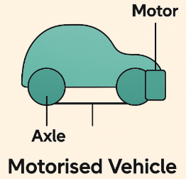  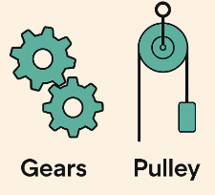  Axle - A rod that allows wheels or gears to rotate.
Key Skills Taught
Develop design ideas using clearly labelled, annotated drawings. Together with notes explaining how pulleys, gears, and motors will work.
Construct a motorised vehicle with working pulleys and/or gears.
Use pulleys to change the direction of a force/ increase mechanical advantage

Key Knowledge Taught: by the end of the unit pupils are expected to know that / be able to:  Understanding mechanisms are a set of moving parts that work together to change movement/ transfer force/ make a task easier.  Identify everyday mechanisms that are used in familiar items e.g cranes, bicycles, lifts or vehicles.  Understand that a pulley is a wheel with a groove that holds a rope, string, or belt. That can change the direction of a force and make lifting or moving easier. That pulleys are useful when a force needs redirecting or reducing effort  Realise that gears are toothed wheels that meshes with another gear. That they transfer rotational movement. Gears help change speed, change direction or change force  Know that gear sizes affect outcome: Large → small = faster speed Small → large = more force |  | Extra Information: This can be added to by teacher, parent or child

