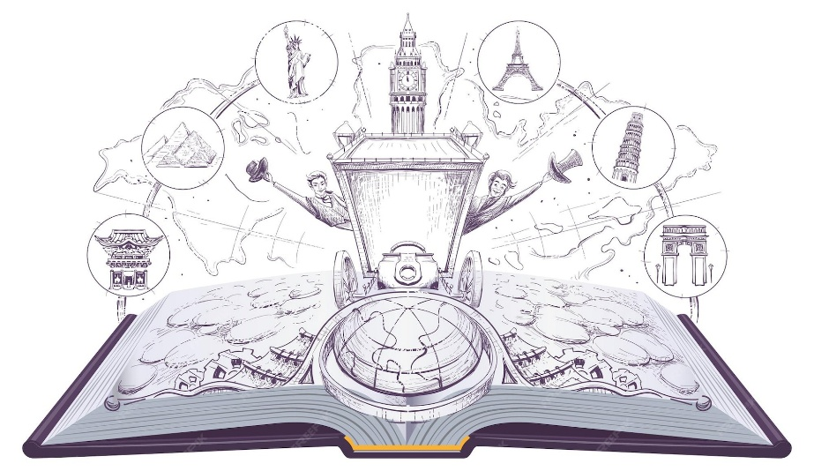
AROUND THE WORLD IN 80 BOOKS
Year 6
1. | Frindle
2. | The Rabbits
3. | This is not a Maths Book
4. | Rose Blanche
5. | Winnie the Pooh
6. | The Explorer
7. | Hunger Games
8. | Freaky Folklore
9. | Under the Sea
10. | Mr Tickle

