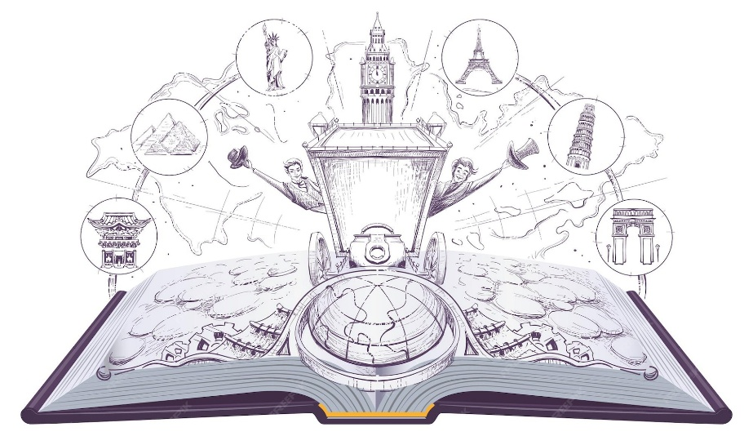
AROUND THE WORLD IN 80 BOOKS
Year 5 SB/KH
1. | Kensuke’s Kingdom
2. | The Rabbit Problem
3. | Our Earth is a Poem
4. | Anisha the Accidental Detective
5. | The Legend of Podkin One-Ear
6. | Varjak Paw
7. | Blackberry Blue
8. | Hidden Figures
9. | Curiosity
10. | Frida Kahlo- Little people Big Dreams

