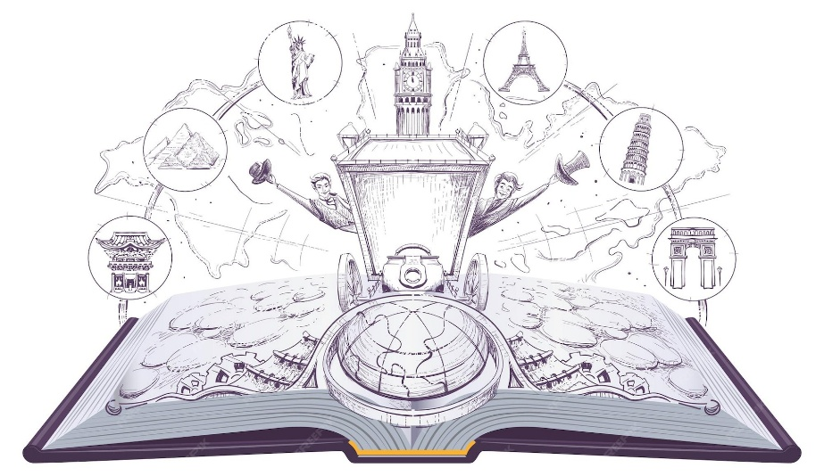
AROUND THE WORLD IN 80 BOOKS
Year 3
1. | The Great Kapok Tree
2. | How many mice make an elephant?
3. | The Last Bear
4. | Escape From Pompei
5. | The cracked pot from a year full of stories
6. | Mirror
7. | Dear Miss
8. | Great women who changed the world
9. | We’re from Australia
10. | Children’s Atlas

