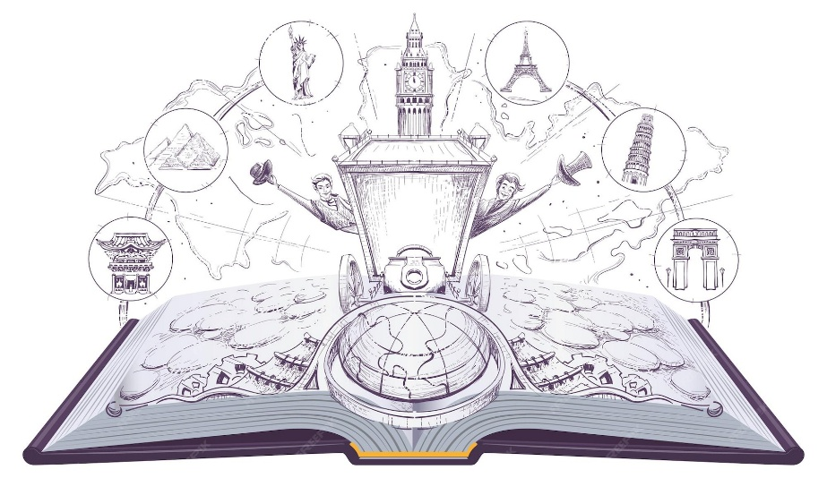
AROUND THE WORLD IN 80 BOOKS
Year 1
1. | The Colour Monster
2. | The day the crayons quit
3. | Oi Frog
4. | The Dot
5. | The Tiger Who Came To Tea
6. | Elmer
7. | Paddington
8. | The Gruffalo
9. | One is a snail. Ten is a crab.
10. | Lost and found

