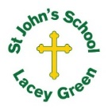
St John’s Church of England Primary School
‘Nurturing Potential for all within a Christian Ethos’

Knowledge Organiser
Prior Learning  - Weather can change day to day (rain, sun, temperature, wind)  - The world is made up of different climate zones (e.g. polar, temperate, tropical)  - Humans use energy, transport, and natural resources  - Fossil fuels such as coal, oil and gas are used to produce electricity  - Maps and atlases can be used to locate countries and continents  - Humans can have both positive and negative impacts on the environment | Year 5/6 – Geography  Spring 1  Climate Change  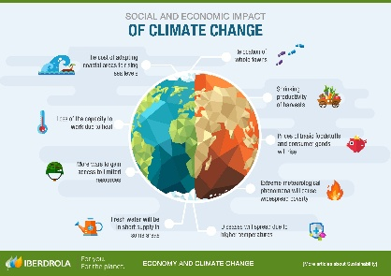 | Vocabulary  Climate – The average weather of a place over a long time.  Climate Change – A long-term change in the Earth’s climate.  Global Warming – An increase in the Earth’s average temperature.  Greenhouse Gases – Gases that trap heat in the Earth’s atmosphere.  Carbon Dioxide (CO₂) – A greenhouse gas released by burning fossil fuels.  Fossil Fuels – Coal, oil and gas formed over millions of years.  Renewable Energy – Energy that won’t run out (wind, solar, hydro).  Emissions – Gases released into the air.  Sustainability – Meeting our needs without harming the future.
Key Skills Taught

Using maps, atlases and globes to locate affected areas.
Interpreting graphs and climate data.
Comparing climates in different regions of the world.
Asking geographical questions and forming opinions.
Explaining cause and effect.
Using correct geographical vocabulary in writing and discussion.
Key Knowledge Taught: by the end of the unit pupils are expected to know that / be able to:  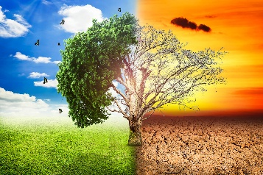  Endpoint: Know what we mean by climate change.  Recognise the issues associated with industry and climate zone.  Know what we mean by ‘greenhouse gasses’.  Know what is meant by ‘ozone layer’.  Know about the campaign of Greta Thunberg and others.  Causes of Climate Change, Effects of Climate Change, How Humans Can Help |  | Extra Information: This can be added to by teacher, parent or child

