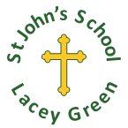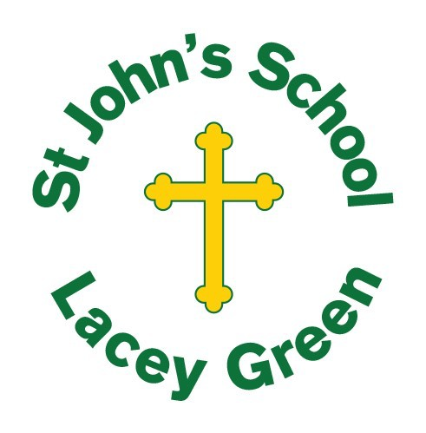
Nurturing all potential within a Christian ethos

At St Johns School we teach the children to strive to be the best person they can be.

Philippians 4:13: I can do all things through Christ who strengthens me.
Overview
At St John’s CE School, Religious Education (RE) plays an important role in expressing the Christian vision of the school. RE reflects the ethos and values that are held and promotes understanding of people of all faiths and worldviews, whether religious or non-religious.
The teaching of RE provides our pupils with opportunities to study religions and relationships. It supports our school vision as children are enabled to better understand and respect the experiences, attitudes, beliefs, and practices of other principal religions represented in this country. Pupils are encouraged to develop a reflective approach to life and connect with themselves, others, the world and beyond. They are given opportunities to make connections to other areas of the curriculum and are encouraged to use their knowledge to form reasoned judgements about religious issues.
Statutory Duty
Every maintained school in England is expected to provide the core curriculum that all pupils are entitled to. (RE, sex education and the National Curriculum). This includes provision for RE for all registered pupils at the school except for those withdrawn by their parents. At St John’s CE School, RE is therefore taught in accordance with the Buckinghamshire Locally Agreed Syllabus, while also reflecting the requirements of the Statement of Entitlement for Religious Education published by the Education Office of the Church of England in February 2019.
The statutory section 48 (SIAMS) inspection will evaluate the way that RE contributes to the Christian character of the school as well as the priority, provision and quality of the curriculum.

The Right of Withdrawal
Pupils may be withdrawn from RE or part of RE by a parent or guardian (or withdrawing themselves if they are aged 18 or over) in accordance with Schedule 19 to the School Standards and Framework Act 1998; teachers can exercise their right to withdraw from teaching the subject. However, we hope that all parents and teachers will feel comfortable with the type of religious education being taught at this school. Parents who wish to withdraw their children must provide written notification to this effect and provide suitable activities for their children. The school will keep pupils safe but will not provide any work or reading material for pupils who have been withdrawn.

Purpose and Aims of RE
The purpose of RE is to teach children about the religious and non-religious worldviews that they will encounter in modern Britain and enable them to engage in meaningful and considered dialogue with those of all faiths and worldviews, whether religious or non-religious. This is religious literacy.

Therefore, the aims of RE in our school are:
- To foster a spiritual development in R.E. by encouraging children to flourish within our Christian vision and values of respect, integrity and resilience.
- To know about and understand Christianity as a diverse global living faith through the exploration of core beliefs using an approach that critically engages with biblical text.
- To gain knowledge and understanding of a range of religions and worldviews appreciating diversity, continuity and change within the religions and worldviews being studied.
- To engage with challenging questions of meaning and purpose raised by human existence and experience.
- To recognise the concept of religion and its continuing influence on Britain’s cultural heritage and in the lives of individuals and societies in different times, cultures and places.
- To formulate reasoned opinion and argument.
- To explore their own religious, spiritual and philosophical ways living, believing and thinking.
- To engage in meaningful dialogue with people of different beliefs and backgrounds, appreciating and celebrating diversity, recognising what we hold in common, and respecting a shared humanity that can be experienced, expressed, and responded to in diverse ways.
Curriculum
The RE curriculum at St John’s CE School, follows the Locally Agreed Syllabus. Christianity is taught in every year group, with key concepts revisited on a spiral curriculum. At least 50% of the time is devoted to Christianity. Other religions are covered according to the syllabus, e.g. Judaism in KS1, Hinduism & Islam in KS2. The total time for RE is between 5% and 10%, and it is taught in dedicated lessons. The time dedicated to RE is separate from the time given to Collective Worship. A longer period of time ( a dedicated theme day) is also allocated in order for classes to explore a particular concept in greater deatil.

Teaching, Learning and Assessment
RE is taught using an enquiry-based approach, that is challenging and robust. At St John’s CE School our approach is based around big questions and an investigative approach, using the Oxford Diocesan Scheme of Work. Learning will be organised to encourage the development of attitudes such as self-awareness, respect for all, open-mindedness, appreciation and wonder, as well as providing opportunities to engage appropriately with fundamental British values. All faiths are treated respectfully, and opportunities will be made to engage in age-appropriate, meaningful discussion. Where possible pupils will encounter believers and visit places of worship.

RE and inclusion
A variety of resources, styles, and techniques will be used as appropriate to enable all children to make progress in RE regardless of their starting points, ability or background.
At St John’s CE School, we believe that RE is an exciting and thought-provoking subject and use a variety of teaching methods, providing all students with access to religious education and to ensure all students are able to make progress in their learning. A range of teaching and learning strategies which are effective for inclusive teaching of religious education include:
- visits to places of worship, museums or art galleries
- representatives from religious traditions and the community as visitors to the class artefacts, big books, posters, videos, artwork
- art and craft to enable students to express their ideas
- use of drama, role play, music, gesture or dance
- music to create an atmosphere or for expression of ideas and emotions
- the use of stillness and periods of quiet reflection
- information and communication technology, such as iPads, interactive whiteboards, websites, etc
Assessment procedures will follow those of the Agreed Syllabus and be in accordance with other assessment and feedback procedures in the school. Students will engage in a variety of activities which will also enable teachers to assess what they have learnt, as well as the quality of the curriculum. Records kept will include information about pupils’ experiences and judgements about their progress, as well as being used to inform planning.
How SMSC is addressed through this subject
In RE lessons, as in all subjects, children are invited to ask questions and reflect on their personal responses to issues. They are asked to consider other people’s responses and appreciate that for some people belief in a spiritual dimension is important. We also encourage children to consider the answers offered by faith groups to questions of meaning and purpose and problems within society and their own experience. Religious education strengthens the school’s vision by helping pupils understand what it means to belong—to a community, to a tradition, and to a wider, diverse world. It introduces them to the variety of communities they may be part of, the ways faith traditions use shared rules to guide moral and ethical choices, and the cultural influences that shape how religious beliefs are lived out.

Monitoring and Evaluation
The RE subject leader and SLT will monitor teaching and learning in RE in accordance with school policy. The RE subject leader will observe teaching, conduct book and planning reviews and pupil interviews when appropriate to assess the quality of teaching and learning. The headteacher and governors will ensure that adequate monitoring takes place and that the impact of such activity is assessed. .

